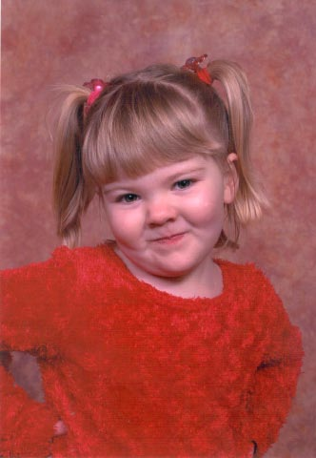
Happy Holidays from the Nelsons
Wow how the 2004 has flown. We’ve enjoyed our tour here and have had many exciting adventures, traveled to many wonderful places, the time has come as we are on our countdown to leave Germany this next summer. Chris has been selected to attend the Neonatal Intensive Care Nursing School in August for 12.5 weeks. The school is at Wilford Hall Medical Center on Lackland AFB in San Antonio, TX. It then looks strong for a follow on assignment at San Antonio! This isn’t fully confirmed yet, but we are hoping! If this does happen, there is a strong chance that we will be in the states intermittently beginning in April or May for house hunting, then for permanent in June/July!

Chris has been blessed with being a nurse at the Contingency Aeromedical Staging Flight(CASF), where he and his team have touched the lives of over 25,000 soldiers, sailors, marines, and airmen that have been in need of medical attention at Landstuhl Regional Medical Facility. The hours that he works are not as crazy as they used to be, but he still keeps busy. This summer, he went to a professional German Soccer game and had a great time. The home team won! He went fishing in a snow storm…..ice was still on the water, so fly fishing was not going well…. In fact, the only people that were catching fish were some Russian Immigrants, and they were fishing in about 20 foot deep water…… flies don’t dive that deep really well…. He also took a trip sponsored by the USO (United Service Organization) that went down to the Black Forest on a fishing trip. He was able to do some real fly fishing in a real stream, and actually caught about 8 fish, which was about 8 fish more then almost everyone else! A couple people did catch some fish, but most went home without. This summer on some days off he also spent time touring the German countryside on his motorcycle. He has a German friend (father of a former co-workers wife) that he rides with….Chris speaks some German, Uli speaks some English…. As long as they aren’t riding, hand gestures work well!!

Kaia will be 4 in January. We don’t know where the time has gone. She is a very independent little girl, who knows what she wants and how to get it. She is very active in gymnastics and continues to leap, tumble and fly thru the house. She started pre-school and loves learning her ABCs and 123s. She loves being the teacher and will read numerous books to who ever will sit and listen. She loves things that match and will change her clothes 5 times a day to ensure that the outfit remains perfect. She loves helping with baking and often adds her own personal touch. More sprinkles or chicken! She had her first pony ride this summer at the Frankfurt zoo and went back for seconds! Since then, horses are even better then before. On stage with Barney the Purple Dinosaur and dancing to the music was also a highlight on this zoo trip. Swimming is still a fun past time and she has started to learn to float on her tummy and blow bubbles. For the last year or so, she and Chris have gone bowling a few times…. Her high score is 103, and she has yet to score less then 70. Of course, this IS with the bumper rails up, but she still has a GREAT time, and it is good daddy/daughter time. She is keeping everyone on their toes and is a joy to watch change and grow up.

Julie has been the quilting queen. She’s made 15 quilts in the last year, some as small as wall hangings and placemats, up to a queen size (and she claims that it would probably fit on a king bed) quilt for our bed! We found a source of pre-cut fabric squares, and this has seemed like cheating to her in a small degree, but has decreased some of the time and frustration in cutting fabric. Some fabric, she still has to cut due to pattern constraints and the fact that not ALL the fabric she wants to use can be found pre-cut! She has decided that she needs a new challenge in her already busy schedule, learning her digitizing software for her embroidery machine. This will allow her to custom make anything that can be embroidered. She’s not taking orders at this time, but will keep you posted. Julie has been on a few trips this year… she went back to Poland again on a shopping trip (this makes 2-3 and she enjoys it, but says it is a LONG day). The Czech Republic was another trip that she took. While she was there, she got a very nice crystal chandelier that we now have hanging in the dining room. She was a substitute pre-school and kindergarten teacher this year and really loved being in the classroom. Julie enjoyed the classroom so much; she is considering returning to school after our return to the states to become education certified so she can teach no matter where we are stationed. Kaia liked her being there as her teacher too. Keeping up a soon to be four year old, Chris’ crazy schedule keeps her hopping; she can’t wait to get back to the USA, and is already actively looking for a house in the San Antonio area in hopes of our projected orders placing us there.

We have been blessed in 2004 and look forward to what God has in store in 2005. Be happy, healthy, and full of peace. We’d love to sit and catch up with each and every one of you; we’ll let you know where we are in 2005.

Christmas Blessings,
Chris, Julie and Kaia Nelson

