28 December 2002

Frohe Weihnachten und Ein GlÜckliches neues Jahr! Merry Christmas and a Happy New Year! I, Denver the Christmas Cat, am again called to serve. This has been a very wild year. Not everything is to MY satisfaction, but that is the way of life for a cat! If you haven’t guessed it yet, we are now living in Germany. Hence, much of my displeasure, but that gets ahead of myself!
We were at Scott Air Force Base in Illinois. Chris decided to transfer from the Primary Care Clinic to the AeroMedical Staging Flight. He moved over in mid February 2002. Three weeks after his move, we were told that we had orders…. This was not due to occur until Jan 03, so this was quite a surprise for the Nelson Family. March through June was all preparation for the “big move.” We had to have passports, arrange to ship our car, arrange to ship all of our furniture, and also to ship me, the cat! July 7 brought us to the airport. Due to the flight time and time zone changes, we arrived in Germany on 8 July. I promptly went to the kennel, as I am not allowed in temporary quarters.
Our first day in Germany was a busy one. We looked at houses, checked into temporary quarters, went to Chris’ new unit to check in, and had a visit to the ER. Kaia had successfully fallen off the bed and cut her cheek…. it was glued back together again instead of stitches. The first of August saw us moving into a house in Bruchmuhlbach. The landlord lives in the Scott AFB area, so the house had some problems. He wasn’t inclined to keep his place up, so we moved into government quarters in Dec (one week before Christmas!). We now live in the city of Kaiserslautern. We are only a 5-minute walk from the city center, so we have done much exploring in the last couple of weeks.

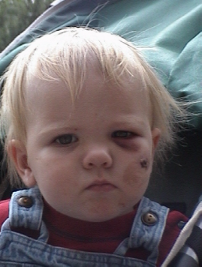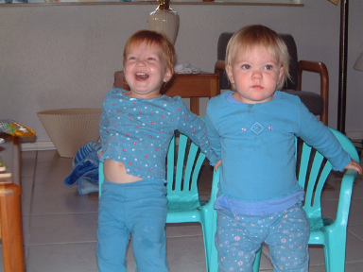
Kaia @ Heidelberg Zoo Kaia “after the Fall” Kaia with best friend Karis

Kaia is now almost 2, and has been going on 20 for the last year! She is ever increasing in her level of independence, most of the time faster then Mom and Dad want. She had two 1st year birthday parties, one with base/military family, and the other with church family. Had lots of fun at both and have pictures and video to prove it! She traveled VERY well for the overseas flight to Germany. Only had one fussy moment, at the Atlanta International Airport. She has made friends and has generally settled into Germany well. She is starting to pick up some of the simple German and will soon be out speaking Mom and Dad both! Her current interests are Winnie the Pooh, Veggie Tales, Care Bears, and Swings/slides. She is now over 30 pounds and is 33+ inches tall! Her vocabulary is growing everyday and becoming easier to communicate with daily.
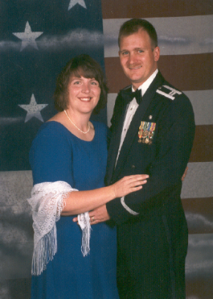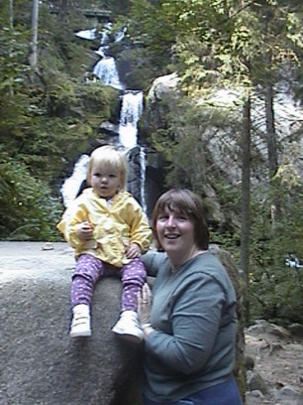
Chris/Julie at Military Ball Julie/Kaia at Black Forest

Julie was very involved with the Officers Spouses Club at Scott AFB, Shiloh Methodist Church, and was doing much in the way of sewing, quilting, and “stamping up” (rubber stamps to make cards, photo albums etc.). The move to Germany was difficult, but she has come through it well. She is still adjusting to Customs, Courtesies, and shopping in Europe. Since getting to Germany, she has continued with sewing and stamping up. Chris took her to the Ramstein Military Ball for their 7th Anniversary so she had the opportunity to dress up and enjoy an evening out! Friends kept Kaia for the entire night, so we had a great time. She has made some very good friends and is keeping VERY busy helping Kaia grow up.

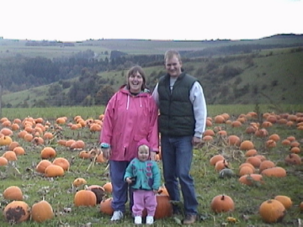
Chris/Kaia Heidelberg Castle Nelson’s picking pumpkins in Germany

Chris moved from Primary Care Clinic at Scott AFB to the AeroMedical Staging Flight (ASF). He was almost done with the orientation when he was notified of the move. He was allowed to stay in the ASF as he was going to be going to the ASF in Germany. He learned to do some fly-fishing and fly tying. Upon arrival to Germany he has been keeping busy learning his job, some local travel with the family, and trying to relearn some of his German language skills?! He is now bowling on the Medical Group bowling league (not doing so hot, but having fun!), and is looking forward to the arrival of his new motorcycle (due to arrive in Jan/Feb 03).
We hope that your 2002 has been filled with joy and happiness, and wish all the same for your 2003. Auf Wiedersehen!
Chris, Julie, and Kaia Nelson (and Denver too!)

Our new address:
PSC 1, Box 3039
APO, AE 09009
E-mail: ctjanelson@yahoo.com

