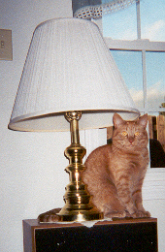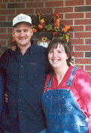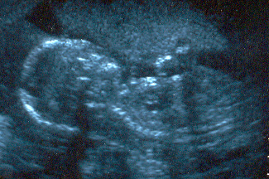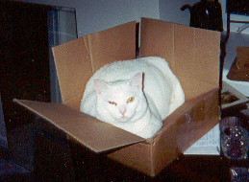
Denver Chris and Julie Baby Nelson due 1 Feb 01 Snowball Mar 97- Nov 00

December 2000

Merry Christmas and a Happy New Year!! The year of 2000 has been a busy one indeed. Hello, I’m Denver, and I am the newly appointed Christmas Kitty at the Nelson household. My predecessor, Snowball became suddenly ill over the Thanksgiving holidays and passed on to the lush green field beyond where mice and sunshine always abound. I will try to do as good a job as she had in the past.
Chris and Julie have thrown the family life into turmoil from the first of the year through now!! In January, we took a LONG ride in a van (I HATE car rides) from Montana to Iowa. Snowball and I were housed for about 30 days in a kennel while Chris and Julie went to Scott Air Force Base just east of St Louis to find us a home. Our first home was a box…. one room that had a fold out bed, kitchen and a bathroom. With the four of us in the place, someone had to leave to change a mind! We stayed there for a month or 2, and then moved into a house in the country. It was LOTS better; with some nice windows that over looked a pond with geese, and our own furniture and stuff! This was much better then before. Then in August we moved into base housing. We now live in a 2-story duplex with lots of room for all! Chris and Julie keep talking about how they are expecting…and something about the 1st of February 01. All I know is my lap space is quickly growing smaller and new, small furniture begins showing up! They have showed family and friends around St Louis, including attractions such as the Zoo, the Arch, Budweiser Brewery, Royal Dump Dinner Theater, and Scott AFB Air Show. They have also seen the Apollo Theater for Gershwin’s Rhapsody in Blue and the Fox Theater for Nutcracker Ballet.
Chris now wears an Air Force uniform every day. He was promoted to 1LT in May. He works as a nurse in a family practice clinic with almost normal hours! We like having him around in the evening. In May he went to Texas for a week of school that taught him about Aero Medical Evacuation Operations. He thought that was cool. In November he went back to Texas for almost 2 weeks for a Combat Casualty Care Course. It was sponsored by the Army and was in the field most of the time, much to his pleasure! He has also received an award for “cutting the red tape” customer service (Skunk Works Award) and gone back to school in the evenings for his master’s degree at Grad School. He has also just recently qualified Expert on the 9MM pistol for the Air Force.
Julie has also been busy this year. She worked as a temp in St Louis for a law firm, and then found something more permanent and closer to home. She now works part time at the base library. She got sick in March and had surgery and is doing much better now. The moves took a toll on her, but her moving furniture is about done now, and she has found almost everything she needs and wants. She is very active in church and church activities and is meeting some neat people that are becoming special friends.
That about wraps up the year. I am quite sure that by next year, I will have MUCH more to tell you. Have a great Holiday Season.

Denver
Official Nelson Christmas-Letter Editor.

